T.M.SAVINDU PASINTHA LAKAMAL MUNASINGHE

Higher National Diploma in Computing & Software Engineering

02/02/2020

Fundamentals in Computer Systems

**Assignment Cover Sheet**

|  |  |  |  |
| --- | --- | --- | --- |
| **Qualification** | | **Module Number and Title** | |
| Higher National Diploma in Computing & software Engineering | | SEC4101 - Fundamentals in Computer Systems | |
| **Student Name & No.** | | **Assessor** | |
| T.M.Savindu Pasintha NG/HNDCSE/24/11 | | Mr. Dhanusha Somawardhana | |
| **Hand out date** | | | **Submission Date** |
| **29/ 11 /2019** | | | **02/02/2020** |
| **Assessment type**  Presentation  Report | **Duration/Length of**  **Assessment Type**  5-7 Minutes (Individual)  1500 – 2500 words (Individual) | | **Weighting of Assessment**  30%  70% |

|  |
| --- |
| **Learner declaration** |
| I, T.M.Savindu Pasintha NG/HNDCSE/24/11, certify that the work submitted for this assignment is my own and research sources are fully acknowledged. |
| |  |  |  |  | | --- | --- | --- | --- | | **Marks Awarded** | | | | | First assessor | |  | | | IV marks | |  | | | Agreed grade | |  | | | Signature of the assessor |  | Date |  | | |

**Feedback Form**

**International College of Business & Technology**

**Module :** Fundamentals in Computer Systems

**Student :** T.M.Savindu Pasintha

**Assessor :** Mr. Danusha Somawardhana

**Assignment:** Netwrix Software Developing Company

**Strong features of your work:**

**Areas for improvement:**

**Marks Awarded:**

**ACKNOWLEDGEMENT**

In preparation of my assignment, I had to take the help and guidance of some respected persons, who deserve my deepest gratitude. As the completion of this assignment gave me much pleasure, I would like to show my gratitude Mr. Dhanusha Somawardhana , our lecturer, on ICBT Campus for giving me good guidelines for assignment throughout numerous consultations. I would also like to expand my gratitude to all those who have directly and indirectly guided me in making this assignment.

**ABSTRACT**

This assignment discussed about “netwrix” software developing company opening new branch .main branch is located in Colombo. They are planning to open a new branch in Kandy. Their business activities will be started within 6 months’ time. In future they are planning to develop websites as well. Firstly, I discussed about what the best useful input devices, output devices, hardware and software for the new branch. I choose, what is the valuable and low cost items in the market for company.

After I discussed, what is best network plan for new branch and how to use network switches, routers, printers, computers and server to the company. Not only that I discussed, how to use computers printers, servers, mobile phones and other electronic devise as a good conditional. Not only that, produce appropriate health and safety policies and discuss the adaptability. Identify possible risk for employee’s health and safety.

**TABLE OF CONTENT**

|  |  |  |
| --- | --- | --- |
| **Acknowledgement** |  | **3** |
| **Abstract** |  | **4** |
| **Introduction** |  | **6** |
| **Task 1** |  |  |
| 1. **Branch manager** | 1. **Laptop** | **8** | |
|  | 1. **Desktop** | **9** | |
| 1. **Programmers** |  | **10** | |
|  | 1. **SOFTWARE DEVELOPMENT TOOLS** | **11,12,13** | |
| 1. **Front office** |  | **14** | |
| 1. **Project manager** |  | **15** | |
|  | 1. **SOFTWARE FOR PROJECT MANAGER** | **16,17,18** | |
| 1. **It administrator** |  | **19** | |
| 1. **Finance department** |  | **20** | |
|  | 1. **SOFTWARE TOOLS FOR FINANCE DIPARTMENT** | **21,22** | |
| 1. **Coordinator** |  | **23** | |
| **Task 2** |  |
| 1. **Netwrix software developing company new branch plan** |  | **25** | |
| 1. **Network devices recommendation** | 1. **Swich** | **26** | |
|  | 1. **SERVERS** | **27** | |
| **Task 3** |  |
| 1. **Laptop ergonomics** |  | **29** | |
| 1. **Desktop ergonomics** |  | **30** | |
| 1. **Mobile phones ergonomics** |  | **31** | |
| 1. **Printer and servers ergonomics** |  | **32** | |
| **Task 4** |  |
| 1. **Gantt chart** |  | **34** | |
| **Conclusion** |  | **35** |
| **Reference** |  | **36,37** |

**INTRODUCTION**

“Netwrix” is a software developing Company. The Company is plan to a new branch in Kandy as a web developing company after hope to success in the business. The company has been divided in to seven parts. Such as branch manager, programmers, front office, project manager, it administrator, finance department and coordinator.

In the first task, I have discussed separately seven components above organization high quality software tools and hardware and their specifications that are appropriately durable and profitable.

In the second task, seven components of the organization are presented with graphical illustrations on how to properly and effectively network the equipment and hardware of the company. In addition, an introduction to networking devices has been introduced.

In the third section above, we present you with detailed and details illustrations of the how to use the hardware and equipment we use safely and healthy. For example, you are well versed in the use of desktop computer, laptop, mobile phones printer and servers safely healthy and safely humanely and appropriately.in the last section, I present to you how I managed my precious time to do this assignment.

TASK 1

1. **BRANCH MANAGER (01 DESKTOP & 01 LAPTOP)**
2. **Laptop (HP PAVILIAN)**

|  |  |
| --- | --- |
| **Device Name** | **Specification** |
| Monitor or Display size | HP 15.6 |
| CPU | Intel core i7 8500U |
| VGA | NVidia GeForce 940MX (2GB) |
| Mouse | Wireless mouse |
| RAM | 8GB DDR4 SDRAM |
| Speaker | 6ohm USB speakers (SAMSUNG basic brand) |
| Storage | 1TB SSD |

**Why I Recommend laptop?**

Branch manager is main person in the software company. He is handled by company.Becours he is very busy. He also responsible for, overseeing sales, creating reports, training, manage the staff members and soliciting feedback forms.Becourse laptop is very use full item for branch manager. I use 15.6inch laptop screen for can easily to see in the display .he can easy carry and handle ito.it is most use full for meetings.

Hp pavilion laptop is the best branded laptop.it has a speed processor as an Intel core i7 8500U.it enough to do more task .because it to I use 8 GB ram, TB (ssd) storage, and 2 GB graphic memory. I thought, wireless mouse is easy to use more than touch pad. (Anon., 2018)

1. **Desktop computer (ASUS BRAND)**

|  |  |
| --- | --- |
| **Device Name** | **Specification** |
|  |  |
| Monitor | 22 inch |
| CPU | Intel i5_8305 |
| VGA | NVIDIA GeForce G7/10807i 4gb |
| Keyboard /MOUSE | WIRELESS |
| RAM | 6 (DDR 4) |
| Hard Disk | 2TB (SATA) |

**Why I Recommend desktop computer?**

I think ASUS brand desk top good for branch manager.becourse branch manager is very busy in him tasks. Some time he want to speed computer for do him task. I recommend 6GB ram, 2TB (sata) storage, 4GB graphic memory and core I-5 processor for desk top. Not only that, 22 inch monitor display is best color support to see. Wireless mouse and key board is very use full for him to doing task. Such as document typing, create to presentations or other graphical and other things.

We can see in most office what pc is an important tool for business work. This pc stores everything that the manage need. Windows 10 software in Microsoft office, Microsoft word

**Not only that I recommend to branch manager,** 6 ohm speakers, and head set, projector and printer. (Anon., 2018)

1. **PROGRAMMERS (10 PC)**

|  |  |
| --- | --- |
| **Device name** | **Specification** |
| VGA | 4GB |
| RAM | 16GB, DDR4 (ASUS) |
| Hard Drive | 3TB(SSD) |
| Monitor | 24 Displays |
| Processor | Intel core i5 -8265U |
| Keyboard | Wire CONNECTED (Asus) |
| Speakers | wireless (HUBER) |
| Mouse | wireless (HUBER) |
| Printer, Scanner | Laser Printer |

|  |
| --- |
| **SOFTWARES** |
| Windows 10 pro latest |
| Office full package |
| Virus guard-kaspass key |
| Media player-km player |
| Web browser-google chrome |
| Android studio |
| Apache net beam |
| Sublimtext |
| Xammp |
| WordPress |
| Wix |
| Angular |
| Laraver |
| Bootstraps ,adobe dream viewer and other software |

**Why I Recommend Its?**

Programmers is mainly very use full person in Software Company. They want to use power full and speed computer to do their task.becouse 16gb ram,4gb graphic memory, 3tb hard drive(ssd) and intel core i-5 8265u processor can speed their computers.24 inch monitor can good graphical output for users.6ohm speaker and head set is use to get out put audio. (Anon., 2018) Not only that they can listen some music’s, songs when doing theirs task freely and enjoying. Sometime wireless mouse and keyboard use their compatibility .windows10os, km player, google chrome are user friendly for programers.angular, laravel, bootstrap, wix, adobe dream viewer, apache net beam, sublime text is easy typing codes for programing projects. Wix, WordPress can online develop web sites, they are easy to use all .android studio can develop android apps or iOS softwares.wix, WordPress have a many sample templates to develop web site.

Below I describe some of use full software development tools for programmers (Anon., 2019)

1. **SOFTWARE DEVELOPMENT TOOLS**
2. **ATOM**

Atom is an open source and free desktop editor cum source code editor that is up-to-date, friendly and hackable to the core (Anon., 2019)

1. **CLOUD 9**

Initially in 2010 Cloud 9 was an open source, cloud-based IDE (Integrated Development Environment) that supports various programming languages like C, Perl, Python, JavaScript, PHP etc. Later in 2016, AWS (Amazon Web Service) acquired it for further improvement and made it chargeable as per the usage. (Anon., 2019)

1. **LINX**

Linx is low code tool to build and automate backend applications and web services. The tool accelerates the design, development and automation of custom business processes, including easy integration of applications, systems and databases. (Anon., 2019)

1. **GITHUB**

GitHub is a powerful collaboration tool and development platform for code review and code management. With this GitHub, the users can build applications and software, manage the projects, host the code, review the code etc. (Anon., 2019)

1. **NETBEANS**

NetBeans is an open source and a free software development tool written in Java that develops world-class web, mobile, and desktop applications easily and quickly. It uses C / C++, PHP, JavaScript, Java etc. (Anon., 2019)

### **BOOTSTRAP**

Bootstrap is an open source and free framework for developing responsive websites and mobile-first projects using CSS, HTML, and JS. Bootstrap is widely used to design faster and simpler websites. (Anon., 2019)

### **NODE.JS**

Node.js is an open source, cross-platform and JavaScript run-time environment that is built to design a variety of web applications and to create web servers and networking tools. (Anon., 2019)

1. **BITBUCKET**

Bitbucket is a distributed, web-based version control system that is used for collaboration between software development teams (code and code review). It is used as a repository for source code and development projects. (Anon., 2019)

### **DREAMWEAVER**

### Adobe Dreamweaver is an exclusive software program and programming editor that is used for creating simple or complex websites. It supports many mark-up languages like CSS, XML, HTML, and JavaScript. (Anon., 2019)

### **ECLIPSE**

### Eclipse is the most popular IDE that is used by Java developers in computer programming. It is used to develop applications not only in Java but also in other programming languages like C, C++, C#, PHP, ABAP etc. (Anon., 2019)

1. **FRONT OFFICE (5 PC)**

|  |  |
| --- | --- |
| **Device name** | **Specification** |
| Mouse | WIRE CONNECTED |
| Hard Drive | 500GB |
| RAM | 4GB, DDR4 |
| Processor | I3_ 8145U (ASUS) |
| Keyboard | wire connected |
| Speakers | wire connected |
| Mouse | wire connected |
| Printer | canon 7250 |

|  |
| --- |
| **SOFTWARES** |
| Windows 8.1 OR 10 |
| MS Office full package |
| Virus guard Kaspersky |
| FIREFOX WEBBROWSER |
| Adobe Photoshop |
| KM player |

**Why I Recommend Its?**

This is a place where a person provides information or registers. As such, this location does not require more efficient devices. Core i-3processor, 4GB RAM (ddr4) and 500GB (sata) hard is improve the computer speed.

It also uses a printing press to make inquiries about the company. I used wire connected mouse, keyboard, 6ohm speaker and canon 7250 color printer for front office.

Windows 8.1 or 10 can use for as an operating system.is is user friendly operating system. Fire fox web browser is open source.km player is use for paly some audio and videos .front office employers can design photos or editing using the photo shop.it has a user friendly interface to create. Microsoft full package is very use full for front office. Word, excel, PowerPoint and other tools will easy to official tasks. (Anon., n.d.)

1. **PROJECT MANAGER**

|  |  |
| --- | --- |
| **Device name** | **Specification** |
| Hard Drive | 2TB (SATA) |
| RAM | 16GB, DDR 2 |
| Monitor | 24 SIZE |
| Processor | Intel core i7 |
| Keyboard | Wire connected |
| Mouse | Wireless |
| Speakers | Wire connected |
| Printer, Scanner | COLOURE |
| VGA | 4GB |

|  |
| --- |
| **SOFTWARES**  Windows 10 pro  Office full package  Kaspersky  Jet audio player  Google chrome  Skype  Photoshop  And other software |

**Why I Recommend Its?**

System one as the person ho organize to other pertness for the purpose use software such high secure virus guard as a Kaspersky, Skype, chrome, Photoshop are used to computer multifunctional and fast and need to work software s it also uses an intel corei7 processor and not only that it use 16gb ram, 2tb hard drive and 4gb graphic memory to maximize efficiency. I chooses color printer and some scanner to get some of printout copies and scan some things.

Additional I use some projector for him.Becoure it is very use full for meetings to show some project and other graphical things. Then all devices are high capacity will must need.

Below I describe some use full software tools for project manager. (Anon., 2020)

1. **SOFTWARE TOOLS** **FOR PROJECT MANAGER**
2. **. PROWORKFLOW** Is a web-based project management software that enables users to manage tasks and projects, track time, organize contacts, and generate reports for their business. It is a productivity application that provides a comprehensive set of features, yet still easy to use for all members of the team. Aside from the great tools and functionality from the software, customers also enjoy free quality support through consultations and trainings that help get their businesses up and running. (Anon., 2020)
3. **. JIRA** Is an agile project management software used by development teams to plan, track, and release software. It is a popular tool designed specifically and used by agile teams. Aside from creating stories, planning sprints, tracking issues, and shipping up-to-date software, users also generate reports that help improve teams, and create their own workflows. As part of Atlas Sian, it integrates with many tools that enable teams to manage their projects and products from end to end. Jira Software is built for every member of your software team to plan, track, and release great software. Every team has a unique process for shipping software. Use an out-of-the-box workflow, or create one to match the way your team works. (Anon., 2020)
4. **. OFFICE TIMELINE** Is a PowerPoint add-in that enables users to create professional-looking timelines and Gantt charts easily. Project plans often get updated because of a variety of factors. However, it can be complex to work on project planning software, especially when what needs to be presented only are the important timelines and milestones. Spreadsheets may be easy to use, but it does not deliver the right visuals for a good presentation. Now, there is an easier way to create impressive timelines and charts using familiar software. (Anon., 2020)

1. **. ZOHO PROJECTS APP** Is an online project management application that helps its users to plan projects, collaborate with employees and clients, keep track of time, manage documents, and generate charts and reports. It is a part of the Zoho business suite. Users work on a central platform where they can keep track of progress, discuss ideas, communicate easily and stay updated. It is cloud-based and highly accessible, where user data is kept safe with stringent security systems. The software is also scalable depending on the number of projects, with the option to add more features. (Anon., 2020)
2. **. ACEPROJECT** is a web-based project tracking software that helps manage projects from end to end. It is a complete project management solution for individuals, teams and enterprises that need to take control of their important workflows and leave nothing to chance. Aceproject provides the tools for projects to remain on time and on budget with its time and expense tracking features. Entering time is very easy, almost automated, and convenient with a Time Clock. Users can easily stay on top of all their projects with a project Dashboard that gives instant information with color-coded graphs and details. With Gantt charts, they can view the intricacies of a project and its progress to be able to make informed decisions and necessary actions.
3. **. PROCORE** Creates schedules, closes rifts faster, tracks project emails, archives documents & photos. Manage submittals, daily logs, change orders, job costing and punch lists. Integrates with MS Project and Sage Timberline Office.
4. **. BUILDERTREND**

Buildertrend is the 1 Software for home builders, contractors & remodels. Our construction software is an all-in-one solution, it features everything you need in one construction app.

1. **. TEAMWORK CRM**

Teamwork CRM helps you to develop your sales process, plan and manage your company’s growth and bring clarity to a chaotic pipeline. No more trying to keep track of your leads across multiple spreadsheets and emails. (Anon., 2020)

1. **IT ADMINISTRATOR (3 PC FOR SERVERS)**

|  |  |  |
| --- | --- | --- |
| DESK TOP OR LAP TOP  INTEL CORE I7  VGA 4GB  RAM 8GB  HARD 2TB | KEYBOARD -WIRE CONNECTED  MOUSE- WIRELESS  WEB CAMER  MONITOR -17  SPEAKER  HEAD SET  PRINTER  UPS | SOFTWARES  OS-windows 10  OFFICE FULL PACAGE  VIUS GUARD-avast premier  km PLAYER  mossilla fire fox BROWSER  adobe PHOTOSHOP cs6  MY SQL |

The role of administrator involves a great deal of multitasking. You will work with teams, oversee the operations within your company, manage groups, coordinate with management and engage in planning according to the needs of your company.

**Why I Recommend Its?**

The company system handled by it administrator. Mainly, backup server and main server stored here.There for 8 GB ram ,4gb graphics memory and 2tb hard drive used it.All the devises handled by this department.so,it want to a more memory capacity .it also requires an intel core I-7 processor. Not only that, it use wire connected key board and wireless mouse. I thought, ups is very use for the power stop.Ups can additional time run the computer system. Speaker and head set is use every time to communication and enjoy songs.

I used it to window 10 OS .it is a very useful and we van easy to use softwares.Mossilla fire fox is open sours web browser. I think avast is use full virus guard for the system security. Microsoft full package have any use full office tools as, word, excel, access and others.

1. **FINANCE DEPARTMENT (3 PC)**

|  |  |  |
| --- | --- | --- |
| DESK TOP  PROCESSOR-CORE I7  VGA-2GB  RAM- 8GB  HARD- 1TB | KEYBOARD -WIRED  MOUSE-WIRED  WEB CAMER  MONITOR-24 INCH  SPEAKER  HEAD SET  PRINTER  UPS | SOFTWARES  WINDOWS 10  OFFICE FULL PACAGE  AVAST PRIMIUM  VCL PLAYER  GOOGLE CROME  OTHER SOFTWARES |

The part of an organization that manages its money. The business functions of a finance department typically include planning, organizing, auditing, accounting for and controlling its company's finances. The finance department also usually produces the company's financial statements.

**Why I Recommend?**

Financial department employers are very important as the persons in charge of all the money and other checks on the departments. For example, it is difficult to operate if the connector he needs is broken. Also the processor is i7 is powerful.22 inch desktop screen is good for them to see in the display. Speaker and head set is use full for him to listen some audios as a communicate with other or enjoy fee time. Microsoft office full package have use full tools for him .windows 10 is best user-friendly interface for him. Google chrome is open source software. They can use VCL player. And avast virus guard for secure the system. Below I explain the useful tools for finance department.

1. **SOFTWARE TOOLS FOR FINANCE DEPARTMENT**

**1. QuickBooks**

QuickBooks is a standard comprehensive financial management tool geared towards small and medium businesses and accountants. It helps you with bank reconciliation, invoices, tracking expenses, payroll, and advanced reporting. There are both cloud and on premise solutions.

While on the more complex side, it’s powerful features offer a compelling reason if you usually deal with high volumes. A small business with limited requirement might find QB a bit overwhelming.

**Suitable for:** Accountants and Enterprises

**2. Kiss flow Finance & Ops Cloud**

While not exactly a finance management tool, Kiss flow is designed to help you develop a system of approval workflows for finance processes. There are pre-built apps for purchase orders, invoices, expense reimbursements or you can create your own, depending on your requirements with zero coding. With standardized approval flows and fairly automated processes, you can make finance process automation a complete breeze. What sets Kiss flow apart is that its visual interface lets you customize the apps based on your needs. There’s no coding required, regardless of the complexity. If your finance processes involve a lot of approvals and repetitive tasks, give Kiss flow a try.

**Suitable for:** SMBs and Enterprises

**3. Zoho Finance Plus**

Zoho’s finance suite breaks down departmental silos and offers an end-to-end integrated platform for all your back-office operations: accounting, invoicing, inventory, expense management, and tax compliance. The suite delivers flexible, scalable, and secure applications to manage your entire finance process.

Every app is accessible from the rest making the usage seamless. The granular user roles limit access based on your needs and you can customize them to the smallest detail.

**Suitable for:** Small and medium businesses

**4. Xerox**

Xerox is an accounting tool that lets you create professional recurring invoices, reconcile bank and credit card statements. It also helps businesses with purchase and sales orders, contact management, payroll and inventory management.Xero is light-weight and easy-to-use.

**Suitable for:** Small and medium businesses

**5. Oracle Financials Cloud**

Oracle Financials Cloud is an ERP system that’s completely based on the cloud. It’s a scalable, comprehensive, and integrated ecosystem of finance tools. While on the expensive side, it might be a good choice for enterprises that look for more control and scalability.

**Suitable for:** Enterprise.

**6. Sage Intacct**

Sage Intacct’s applications are suitable for small and midsize companies, helping them manage the general ledger, accounts payable, accounts receivable, cash management and order management. With an open API structure, you can integrate them with other business applications like CRM, payroll, or POS systems.

**Suitable for:**Though enterprises find the value, it may not be the same for small and medium business. (Anon., 2020)

1. **COORDINATORS (3 PC)**

IT coordinators, also referred to as managers, are responsible for determining, developing and implementing an organization's information technology goals. Their activities can include reviewing and filling internal help requests and monitoring computer performance for potential problems.

|  |  |  |
| --- | --- | --- |
| **Device** | **Specification** | **SOFTWARES** |
|  |  |  |
| Hard drive | 1TB (SATA) | WINDOWS 10 OS |
| RAM | 4GB DDR4 | KASPAS KEY |
| Monitor | 24 INCH displays | KM PLAYER |
| Processor | Intel core I5-8265U | FIREFOX WEB BROWSER |
| Keyboard | wire | PHOTOSHOP |
| Speaker | 6 ohm (wire ) | AVAST VIRUS GUARD |
| Mouse | wireless | OFFICE FULL PACAGE |
| Web cam | wire connected | MYSQL SERVER |
| Projector |  |  |
| Printer | Hp |  |

Why I Recommend Its?

Windows10 is easy to use any one. Intel core i5 with 4GB RAM and 1TB SATA for fast, accurate and information and storage.24-inch display for better screen space and view. Wired mouse and keyboard to avoid misplacement. Headphones for communication purposes. (Anon., 2007).

TASK 2



1. **Network device recommendation**
2. What is the

**Switch**?

* A network switch is a hardware device that channels incoming data from multiple input ports to a specific output port that will take it toward its intended destination. It is a small device that transfers data packets between multiple network devices such as computers, routers, servers or other switches. (Anon., 2012)
* The branch manager has a switch with 4ports. Because it has computer and lap top.
* Programmers use switch with 16 ports. It has 10 computers.
* The front office has 4desktops, and one laptop. I think future can connect other computer for it.Becouse 16ports Swich used for networking.
* Department 3 IT administrator has a switch with 32 ports is used. All the networks and printer and router connect with this Servers in this department.
* A project manager is working in company and he has been given a laptop and a printer to facilitate his work. The project manager’s department uses 4port switch on the network.
* Finance department use 2 desktop computer and one lap top use a switch with 4port switch for networking.
* The coordinators are used 2 desktop computer and laptop use a switch with a 4ports used for networking.
* Firewall will give company to secure internet connection. Internet connection connect firewall, firewall is connect to the router.

1. What is the

**Server?**

* Web Server, application server, mail server, virtual server, file server, policy server.

A Central database is known as a frequent server for database processing and computer .IT also supports other computer related applications.

* **Server Operating Systems ---** Microsoft Windows, Unix , Ubuntu , Solaris

usually found the their clients and clients are supports in the development of for java , Active x and “plug _ins” the client just download to data and process it as the user, s end user can carry out many operations for every requested than faster rate should be accessing the server site.

* A server Improves, A server makes for faster , A server automated backup system

Then it is any damage to a shared computer will cause the components to fail power supply, hard drive, Motherboard. (Anon., 2020)

TASK 3

1. **LAPTOP ERGONOMICS**

* Use a full size keyboard and tracking device whenever possible.
* Drop laptop up so top of screen is level with eyes.
* Incorporate mini-breaks every 20-30 minutes.
* Maintain about an arm’s length viewing distance.
* Keep your ears, shoulders and hip in alignment.
* Position the keyboard and elbow height and keep your wrist straight while keying.
* Remember when seated your hips should be slightly higher than your knees.
* If you are seated in a side chair or couch, use a pillow support, your arms while knees.
* Clean the screen regularly using appropriate antistatic cleaning materials.
* The hand and wrists should be kept in a straight a when typing should not be resting palm rest, table or lap while typing. (sirajudeen, 2008)

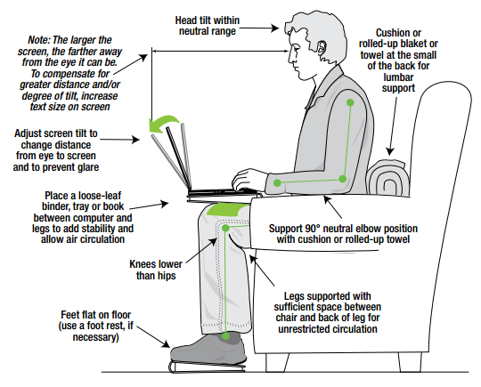

1. **DESKTOP ERGONOMICS**

* Ensure to keep natural head position always.
* Always relax your shoulders and back straight.
* Ensure to keep elbows close to body at a 90-100degrees angle.
* Get support to natural back arch.
* Maintain the hip angle 90-100 degrees.
* Keep knee angle 90-100degrees.
* You can use footrest rest to keep your foots.
* Try to maintain top of monitor level with eyes.
* Monitor length should be about an arm’s length away.
* Try to keep your wrist in straight line with forever. (sirajudeen, 2008)

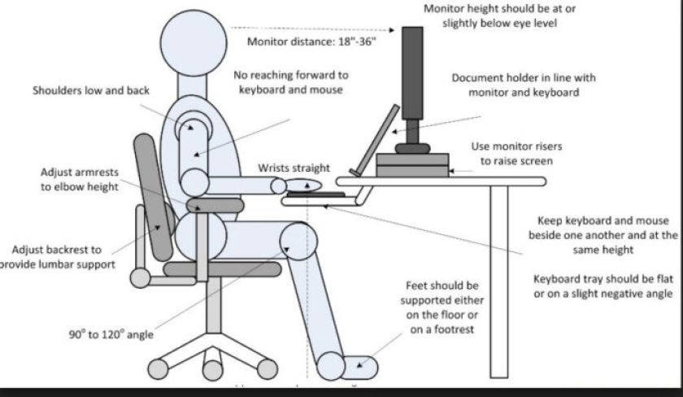

1. **MOBILE PHONES ERGONOMICS**

* Smart phone have become a part of our live in the days to days basic. They make easy to communicate for work and with friend and family, and there are lungless way to be entertained
* In today society people have used to be spending half of the day on a smart phone where many injuries are happening to our body.
* Tips for using smart phone ergonomically.
* Keep a reasonable distance between the eye and your mobile phone.
* Make some lightning in the room allows go to easily see what is on the srceen.adjust the brightness that to your eyes.
* Keep the volume of your phone in a reasonable level.
* Holding phone up to our ear can lead to problem with elbows, neck and shoulders.

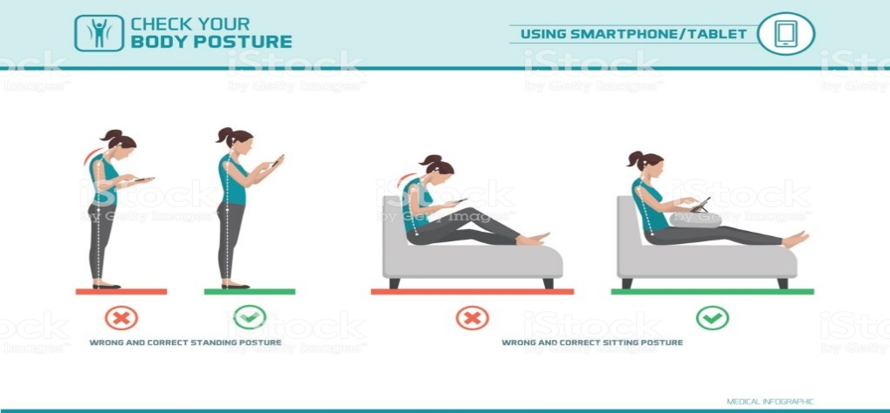

1. **PRINTER AND SERVER ERGONOMICS**

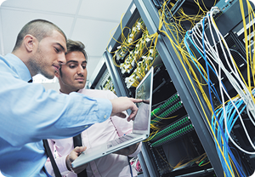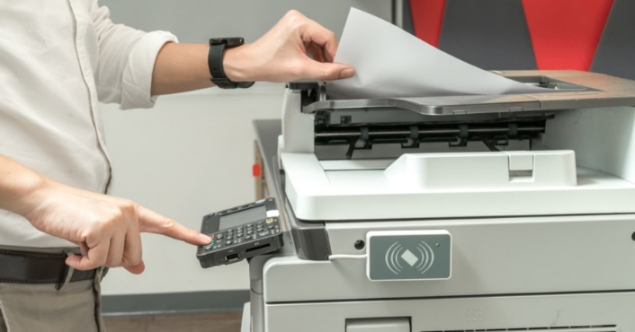

* Working conditions that do not pace a rise of sours harm.

* Receive information and training about workplace methods to prevent them and the matching standard that apply to the workplace.
* Review records of work related injuries and illness.
* Exercised their right under the law without relation, including reporting a murky or raising health and safety concerns with employers. (Anon., 2020)

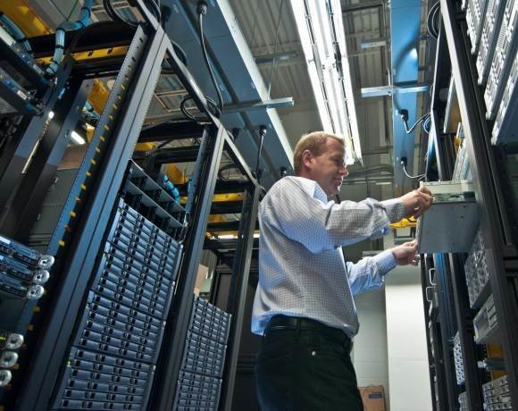

Task 4

**GRANTT CHART**

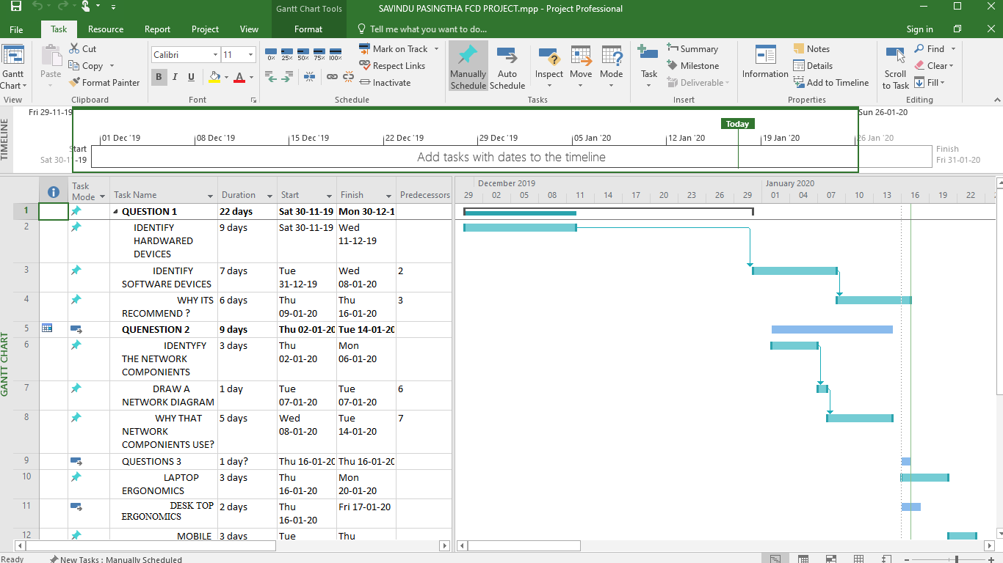

**CONCLUTION**

I have worked with the internet and my knowledge in order to make these assignment more accurate. I have done my best to make sure that I have the right software, the right hardware and devises for the start-up.in addition, I have explained how to use them properly, safely and safety. I have also explained to you the network diagram of the hardware and organization of the organization and how they should be installed.in addition, this assignment will clearly show you how to use your laptops/desktops, mobile phones/tablets, printers and servers in a healthy and accurate manner. By doing this assignment I have explained my knowledge of computers, hardware, software and its installations.

This assignment is important for expanding my knowledge and will be useful for someone else to improve their knowledge.

# REFERENCES

1. Anon., 2012. *Computer Network* Anon., 2007. *101 of the Best Free Computer Software For Windows PC - Make Tech Easier.* [Online]   
   Available at: https://www.maketecheasier.com/best-101-free-computer-software-for-your-daily-use/  
   [Accessed 18 1 2020].*Components.* [Online]   
   Available at: https://beginnersbook.com/2019/03/computer-network-components/  
   [Accessed 20 1 2020].
2. Anon., 2017. *Lewistonschools.net.* [Online]   
   Available at: ww.lewistonschools.net/informationtechnology/new-computer-specifications/#PC_Desktop_Hardware_Specifications  
   [Accessed 22 12 2019].
3. Anon., 2018. *Features of a Good Laptop: Laptop Specifications List - LaptopHungry.* [Online]   
   Available at: https://laptophungry.com/laptop-specifications-list/  
   [Accessed 17 12 2019].
4. Anon., 2018. *I built a $2000 custom gaming PC.* [Online]   
   Available at: https://www.theverge.com/2018/9/13/17828092/gaming-pc-build-custom-how-to-asus-intel-geforce-cost  
   [Accessed 28 12 2019].
5. Anon., 2018. *PC specs for a programmer.* [Online]   
   Available at: https://linustechtips.com/main/topic/903286-pc-specs-for-a-programmer/  
   [Accessed 27 12 2019].
6. Anon., 2019. *20 BEST Software Development Tools (2020 Rankings).* [Online]   
   Available at: https://www.softwaretestinghelp.com/software-development-tools/  
   [Accessed 17 12 2019].
7. Anon., 2019. *Best Web Development Frameworks Comparison - PixelCrayons.* [Online]   
   Available at: https://www.pixelcrayons.com/blog/best-web-development-frameworks-comparison/  
   [Accessed 19 12 2019].
8. Anon., 2020. [Online]   
   Available at: https://www.pmi.org/learning/library/choosing-computer-system-project-management-1951  
   [Accessed 2 1 2020].
9. Anon., 2020. *Best Financial Management Software | 2020 Reviews of the Most Popular Tools & Systems.* [Online]   
   Available at: https://www.capterra.com/financial-management-software/  
   [Accessed 16 1 2020].
10. Anon., 2020. *Best Project Management Software | 2020 Reviews of the Most Popular Tools & Systems.* [Online]   
    Available at: https://www.capterra.com/project-management-software/  
    [Accessed 3 1 2020].
11. Anon., 2020. *Computer Basics: 10 Examples of Output Devices.* [Online]   
    Available at: https://turbofuture.com/computers/Computer-Basics-10-Examples-of-Output-Devices  
    [Accessed 15 1 2020].
12. Anon., 2020. *Ergonomics in the Printing Environment | Engineered Printing Solutions.* [Online]   
    Available at: https://www.epsvt.com/ergonomics-in-the-printing-environment/  
    [Accessed 27 1 2020].
13. Anon., 2020. *What is a Server?.* [Online]   
    Available at: https://www.computerhope.com/jargon/s/server.htm  
    [Accessed 23 1 2020].
14. Anon., n.d. [Online].
15. Anon., n.d. [Online]   
    Available at: https://www.capterra.com/financial-services-software/  
    [Accessed 15 december 2019].
16. Anon., n.d. *System Requirements for eZee FrontDesk Hotel PMS.* [Online]   
    Available at: ps://www.ezeefrontdesk.com/systemrequired.php  
    [Accessed 23 12 2019].
17. sirajudeen, m. s., 2008. [Online]   
    Available at: https://www.researchgate.net/publication/316348213_Knowledge_of_Computer_Ergonomics_among_Computer_Science_Engineering_and_Information_Technology_Students_in_Karnataka_India  
    [Accessed 25 1 2020].

**End !**